KIET Website Required Content

- 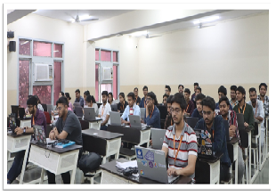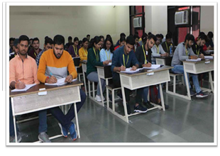

DEPARTMENT PAGE

- Departments Image (1920px * 500px)
Requested to get from ITSS

- HOD Name : Dr. Ajay Kumar Shrivastava
- NBA Accreditation : .NBA Accredited (Valid from 2024 for 3 years)
- Intake: 240
- Overview of the department:
Department of Computer Science was established in the year 2018, with the objective of imparting quality education in the field of Computer science. The department aims to be the Centre of Excellence in providing international standard education and consultation in the field of computer science and thus targets to produce globally competent and self disciplined computer engineers. With rapidly evolving technology and continuous need for innovation, the department has always produced quality professionals, holding important positions in information technology industry in India and abroad.

